**Career Development Analysis Dashboard**

Date: [9th August 2024]

Author: [Archita Sharma]

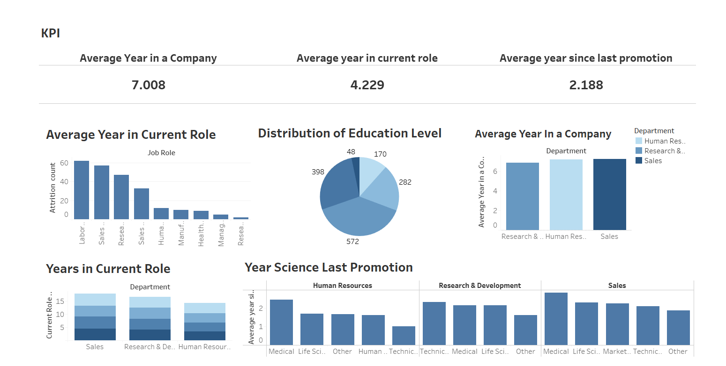

**Overview:** The Career Development Analysis Dashboard provides a comprehensive overview of key performance indicators (KPIs) related to employee tenure, roles, and educational distribution within a company. The dashboard visualizes critical data points such as the average years employees have spent in the company, in their current role, and since their last promotion. Additionally, it breaks down attrition rates by job role and department, and examines the distribution of education levels among employees.

**Key Performance Indicators (KPI):**

1. **Average Year in a Company: 7.008**
   * This KPI indicates the average tenure of employees within the company, suggesting overall employee retention and satisfaction.
2. **Average Year in Current Role: 4.229**
   * This metric highlights the average time employees spend in their current roles, providing insights into role stability and potential career growth opportunities within the organization.
3. **Average Year Since Last Promotion: 2.188**
   * This figure reflects the average duration since employees received their last promotion, which could be indicative of promotion frequency and career advancement practices.

**Detailed Analysis:**

1. **Average Year in Current Role by Job Role:**
   * The bar chart shows attrition counts across various job roles, with the highest attrition observed in the Laboratorial roles, followed by Sales and Research roles. This could imply areas where employee retention strategies need to be focused.
2. **Distribution of Education Level:**
   * The pie chart reveals the distribution of employees' education levels. The largest segment, 572 employees, falls into a particular education category, followed by 398, 282, 170, and 48 employees in other categories. Understanding this distribution can help tailor development programs and recruitment strategies.
3. **Average Year in a Company by Department:**
   * This bar chart compares the average tenure of employees across different departments. Sales, Human Resources, and Research & Development are the departments highlighted, with Sales having the highest average tenure, suggesting higher employee retention.
4. **Years in Current Role by Department:**
   * The stacked bar chart displays the distribution of years employees have spent in their current role across different departments. Sales, Research & Development, and Human Resources departments are compared, showing variance in role stability and possible growth opportunities.
5. **Years Since Last Promotion by Department and Industry:**
   * The final chart compares the average years since the last promotion across different industries within three departments: Human Resources, Research & Development, and Sales. This data can be useful to identify departments where promotions are more or less frequent, potentially guiding career development initiatives.

**Conclusion:** This HR Analytics Dashboard offers valuable insights into employee tenure, role stability, and educational background across the organization. By analyzing this data, companies can identify areas of strength and opportunities for improvement in their HR strategies, particularly concerning employee retention, promotion practices, and targeted development programs.